Pass Task 5+6+9 –

Shape Drawer

# Related Learning Outcomes

# ULO1 – Explain the OO Principles

The task explains the concept of aggregation in Object-oriented programming.

# ULO2 – Use OO Language and Library

This exercise provides a basic example of coding a program in C# using the SwinGame library.

# ULO3 – Design, Develop and Test using an IDE

The task demonstrates how to use perform testing on program algorithm with nUnit in Xamarin Studio

Task 9 also demonstrates the process of Test Driven Development and how to apply it with Xamarin Studio.

# ULO4 – Communicate using UML Diagrams

The task shows how to demonstrate aggregation in UML diagrams.

# ULO5 – Describe Elements of Good OO Design

Code running

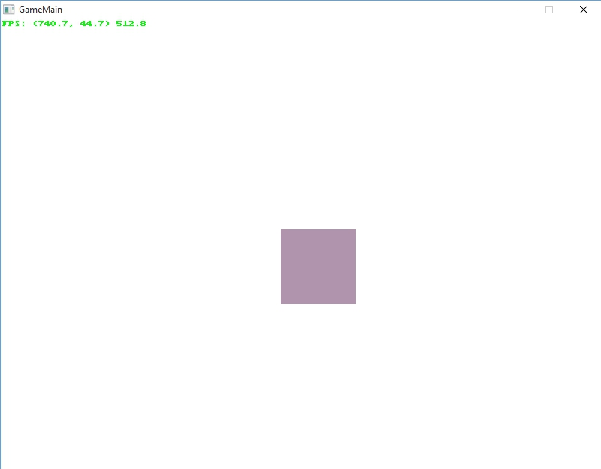

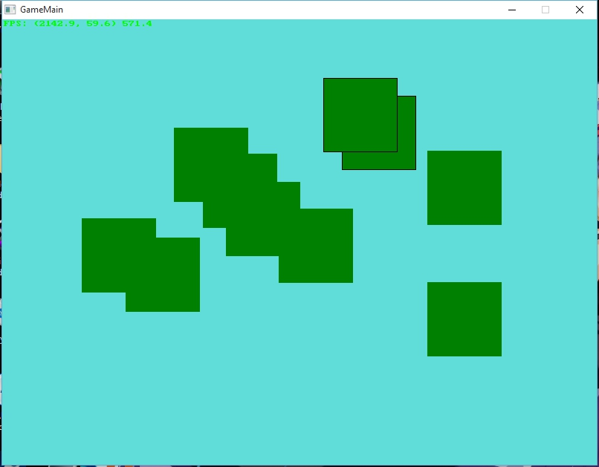

Unit Testing:

